**(GDD)**

LED String Animation

Contents

**1.** **Document History** 3

**1.1.** **Revision History Table** 3

**1.2.** **Current** **Document** **Status** 3

**2.** **Project Description** 3

**3.** **Block Diagram** 4

**4.** **Feature Description** 5

**4.1.** **Start Up Requirements** 5

**4.2.** **Tail Function Requirements** 8

**4.3. Turn Indicator (TI) Requirements** 10

**5.** **Reference Documents Table** 13

# **Document History**

## **Current Document Status**

|  |  |  |  |
| --- | --- | --- | --- |
| Version | Status | Author | **Date** |
| 1.0 | Draft | Caroline - Mark | 28/02/2020 |
| 1.1 | Draft | Mahmoud Hamdy | 28/02/2020 |
| 1.2 | Draft | Caroline | 28/2/2020 |
| 1.3 | Draft | Mirna | 28/2/2020 |

## **Revision History Table**

|  |  |  |  |
| --- | --- | --- | --- |
| Version | Author | Date | Change |
| 1.0 | Caroline - Mark | 28/02/2020 | Initial Creation |
| 1.1 | Mahmoud Hamdy | 28/02/2020 | Added timer component to architecture and to APIs |
| 1.2 | Caroline | 28/2/2020 | Added DIO APIs |
| 1.3 | Draft | Mirna | Added LED_Animation_voidSetLedON & LED_Animation_voidSetLedOFF |

# **Reference Documents Table**

|  |  |  |  |
| --- | --- | --- | --- |
| Ref. number | Doc. Name | Version | Status |
| 1 | LED_STRING_ANIMATION_CYRS | 1.6 | Proposed |
| 2 | LED_String_HSI | 1.6 | Proposed |

# **Project Description**

The project is composed of 3 sets of LED Strings Simulating the animation of LEDs in a Car, One set is named “Tail” and it simulates the animation of car’s back LEDs while the other 2 sets are named “Left TI” and “Right TI” is simulating the animation of left and right turn indicator in a car.

Each one of the 3 functions operates based on input signals coming from 3 switches named “Tail Switch”, “Left TI” and “Right TI” respectively in addition to “Welcome Mode” which shall operates one of 2 different modes based on the status of the mode switch. System layout is as shown in **Figure 1** below.

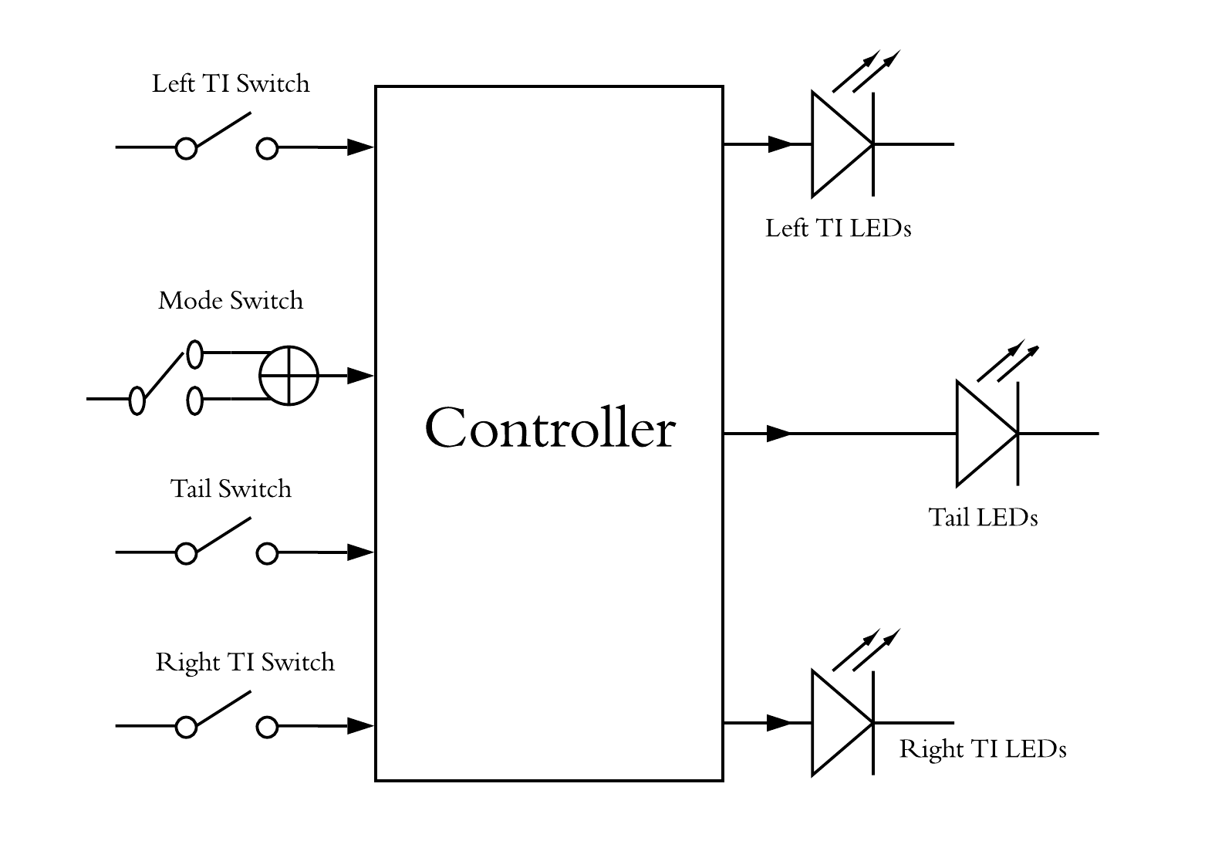

Figure 1: layout of the system

# **Software Context Diagram**

LEDs Manager

Switches Status

Handler

LEDs Status

LED Handler

Switch Manager

# **Input Output Signals**

* Mode Signal

LED Animation Algorithm

Signal_Mode

Signal_LEDsData

LEDs

Mode

Switch

|  |  |  |
| --- | --- | --- |
| Signal | Range | Unit |
| Signal_Mode | 0-1 | Uint8_t |
| Signal_LEDsData | - | LEDString_t |

* TIR Signal

Signal_LEDsData

Signal_TIR_Mode

LED Animation Algorithm

LEDs

TIR

Switch

|  |  |  |
| --- | --- | --- |
| Signal | Range | Unit |
| Signal_TIR_Mode | 0-1 | Uint8_t |
| Signal_LEDsData | - | LEDString_t |

* TIL Signal

Signal_LEDsData

Signal_TIL_Mode

LED Animation Algorithm

LEDs

TIL

Switch

|  |  |  |
| --- | --- | --- |
| Signal | Range | Unit |
| Signal_TIL_Mode | 0-1 | Uint8_t |
| Signal_LEDsData | - | LEDString_t |

* Tail Signal

Signal_LEDsData

Signal_Tail_Mode

LED Animation Algorithm

LEDs

Tail

Switch

|  |  |  |
| --- | --- | --- |
| Signal | Range | Unit |
| Signal_Tail_Mode | 0-1 | Uint8_t |
| Signal_LEDsData | - | LEDString_t |

# **Software Features**

LEDs Control Features

Input Feature

Output Feature

Switches_Status_Signal

Signal_Mode

Signal_Tail_Mode

Signal_TIR_Mode

Signal_TIL_Mode

Microcontroller Feature

# **Static Architecture**

APPLICATION

LIB

Std_Types

LED_Animation

HAL

Switch

LED

Bit_Man

MCAL

DIO

Timer

# **APIs**

* LED_Animation
* Types

|  |  |
| --- | --- |
| Name | LEDString_t |
| Type | Structure |
| Range | - |
| Description | Data structure containing the set of configuration parameters required for setting the leds status |

|  |  |
| --- | --- |
| Name | LED_Animation_Tail_State |
| Type | Enumeration |
| Range | LED_ANIMATION_TAIL_ON |
| LED_ANIMATION_TAIL_OFF |
| Description | The state of the tail LEDs |

|  |  |
| --- | --- |
| Name | LED_Animation_Running_Mode |
| Type | Enumeration |
| Range | LED_ANIMATION_MODE_WELCOME_1 |
| LED_ANIMATION_MODE_WELCOME _2 |
| LED_ANIMATION_MODE_TI_1 |
| LED_ANIMATION_MODE_TI_2 |
| LED_ANIMATION_MODE_NONE |
| Description | The state of the tail LEDs |

* Function definitions

|  |  |
| --- | --- |
| Name | Timer_voidInit |
| Parameters | Timer Overflow Value (u32) |
| Return Value | None |
| Description | Initializes the timer by enabling its interrupt and setting the value at which the timer will overflow |

|  |  |
| --- | --- |
| Name | Timer_voidStart |
| Parameters | None |
| Return Value | None |
| Description | Starts the timer at the specified instant |

|  |  |
| --- | --- |
| Name | Timer_f64GetTimeMillis |
| Parameters | None |
| Return Value | Time in milliseconds (Variable will be of "double" type) |
| Description | Returns the time elapsed since the start of the timer in milliseconds |

|  |  |
| --- | --- |
| Name | LED_Animation_voidInit |
| Parameters | None |
| Return Value | None |
| Description | Initializes all the LEDs and Switches required for the application |

|  |  |
| --- | --- |
| Name | LED_Animation_voidSetFlags |
| Parameters | None |
| Return Value | None |
| Description | Reads all the switches status and sets all the flags that represents the LEDs animation |

|  |  |
| --- | --- |
| Name | LED_Animation_voidStartAnimationMode |
| Parameters | None |
| Return Value | None |
| Description | Reads all the flags status and starts the suitable animation mode according to switches status |

**[Req_ PO5_LSAN_ LED STRING ANIMATION_03_V01]**

**[Req_ PO5_LSAN_ LED STRING ANIMATION_04_V01]**

|  |  |
| --- | --- |
| Name | LED_Animation_voidSetTailLeds |
| Parameters | None |
| Return Value | None |
| Description | Sets the tail leds on and off according to the tail flag state |

**[Req_ PO5_LSAN_ LED STRING ANIMATION_01_V01]**

|  |  |
| --- | --- |
| Name | LED_Animation_voidRunModeOne |
| Parameters | None |
| Return Value | None |
| Description | Runs the animation of mode 1 which is described in the LED_STRING_ANIMATION_CYRS |

**[Req_ PO5_LSAN_ LED STRING ANIMATION_02_V01]**

|  |  |
| --- | --- |
| Name | LED_Animation_voidRunModeTwo |
| Parameters | None |
| Return Value | None |
| Description | Runs the animation of mode 2 which is described in the LED_STRING_ANIMATION_CYRS |

**[Req_ PO5_LSAN_ LED STRING ANIMATION_05_V02]**

**[Req_ PO5_LSAN_ LED STRING ANIMATION_06_V01]**

|  |  |
| --- | --- |
| Name | LED_Animation_voidRunTI_Right |
| Parameters | None |
| Return Value | None |
| Description | Runs the animation of TI right mode which is described in the LED_STRING_ANIMATION_CYRS until the TI right switch is released |

**[Req_ PO5_LSAN_ LED STRING ANIMATION_07_V02]**

**[Req_ PO5_LSAN_ LED STRING ANIMATION_08_V01]**

|  |  |
| --- | --- |
| Name | LED_Animation_voidRunTI_Left |
| Parameters | None |
| Return Value | None |
| Description | Runs the animation of TI left mode which is described in the LED_STRING_ANIMATION_CYRS until the TI left switch is released |

|  |  |
| --- | --- |
| Name | LED_Animation_voidSetLedON |
| Parameters | LEDString_t |
| Return Value | None |
| Description | Turn a specific LED ON |

|  |  |
| --- | --- |
| Name | LED_Animation_voidSetLedOFF |
| Parameters | LEDString_t |
| Return Value | None |
| Description | Turn a specific LED OFF |

|  |  |
| --- | --- |
| Name | DIO_SetPinDir |
| Parameters | Port_No , Pin_No , Direction |
| Return Value | ErrorStatus |
| Description | Configures the Pin Direction Input/Output |

|  |  |
| --- | --- |
| Name | DIO_SetPinVal |
| Parameters | Port_No , Pin_No , Value |
| Return Value | ErrorStatus |
| Description | Configures the Pin Value High/ Low |

|  |  |
| --- | --- |
| Name | DIO_GetPinVal |
| Parameters | *PTR_Value |
| Return Value | ErrorStatus |
| Description | Reads the Pin Value High/Low |